About the Trainer
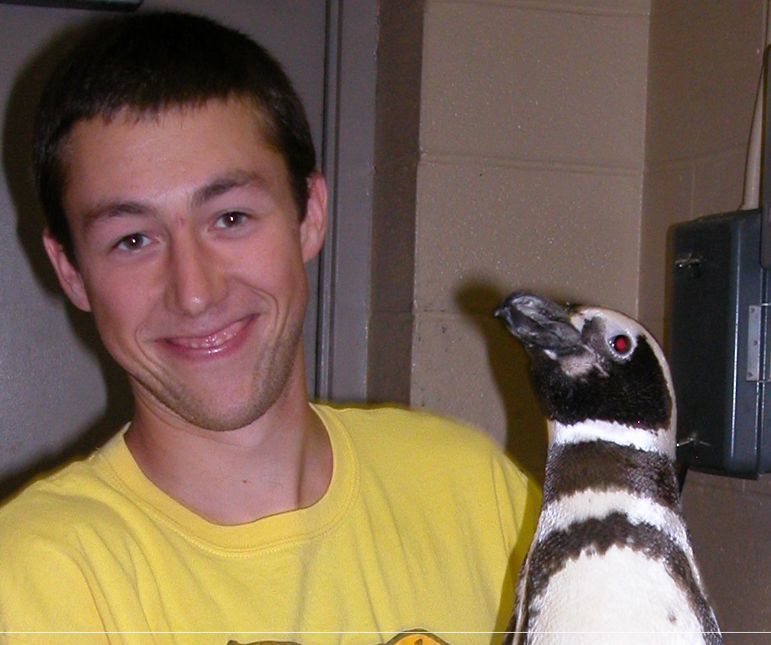
Steve Ploetz
c. (513) 368-3824
Dogcountrydaycare.com

After obtaining a B.S. in Wildlife Biology, Steve studied and worked with birds before honing his skills in the canine world. Combining a simple and positive approach, Steve teaches classes and hands on learning for dog trainers and beginners alike. Steve has extensive experience in managing off leash dog play. With a specialty in socialization, Steve teaches progressive classes in all types of real world settings.
Steve enjoys hiking and rock climbing with his two rescue dogs, Joe and Lady in his free time.
